# Data Collection

From the AMS Local Food Economics Data Warehouse, “Local Food Sales” tab,



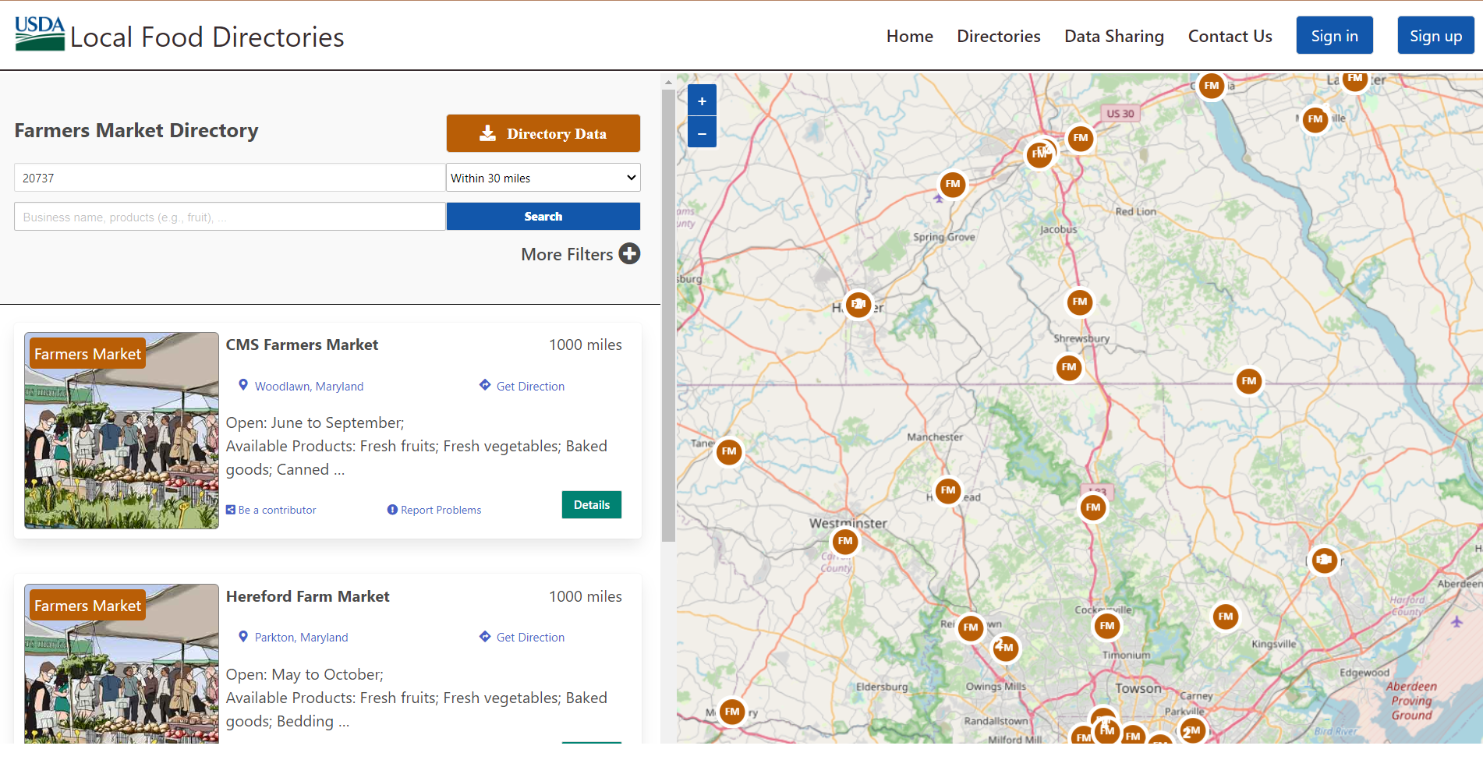

USDA FSIS MPI Directory Data

### **Steps for Processing** [**Food Safety and Inspection Service (FSIS): Meat, Poultry and Egg Product Inspection (MPI) Directory**](https://www.fsis.usda.gov/inspection/establishments/meat-poultry-and-egg-product-inspection-directory)**[1]** [**Data**](https://www.fsis.usda.gov/inspection/establishments/meat-poultry-and-egg-product-inspection-directory) **and Geocoding in ArcGIS Pro**

1. **Download the MPI Directory data from FSIS** 
   * 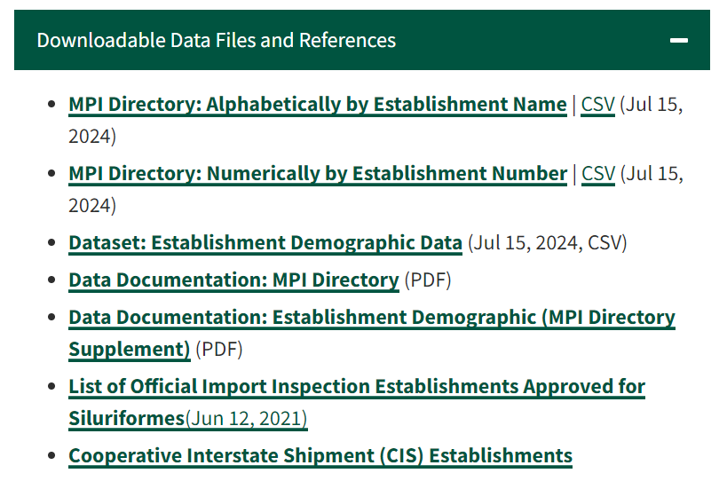
2. **Filter FSIS Dataset**
   * Retain only facilities categorized as meat slaughter, poultry slaughter, and voluntary slaughter.
   * Join tables using establishmentID to consolidate address information.
   * Exclude null entries in columns slaughter and process to remove non-processing facilities, reducing the dataset from 7,000 to 5,000 entries.
   * Save the filtered dataset in Microsoft Excel.
3. **Further Narrow Down the Data in Excel**
   * In Excel, duplicate the table and create a helper column with the equation =OR(SDF>,SDFA>0) to identify non-null processing or slaughter volumes.
   * Filter the helper column by TRUE, delete the helper column, and clear filters.
   * Save the refined dataset for use in ArcGIS.
4. **Geocode in ArcGIS Pro**
   * Import the refined Excel files into ArcGIS Pro.
   * Use the ArcGIS geocoding service to convert address data to geographic coordinates.
   * Geocode only within our target region (CT, DE, DC, ME, MD, MA, NJ, NY, PA, RI, VT, NH) to reduce processing time.
   * Choose geocoding settings that approximate addresses at the building’s mailbox or by the road for accurate drive time calculations.
5. **Upload and Join Data in ArcGIS Pro**
   * Upload the cleaned dataset back into ArcGIS as a standalone table.
   * Join the filtered dataset with the facility table containing geocoded geographic information.
   * Ensure no features are selected before performing the join to include all target features.
   * Use establishmentID as the attribute relationship for the join.
   * Perform the join with settings to keep all target features, ensuring a complete dataset.
6. **Verification and Mapping**
   * Verify the accuracy of the geocoded locations using the imagery map in the ArcGIS basemap.
   * Right-click on locations and select "What's Here" to double-check the information against visual data.

# Data Processing

# Data Mapping

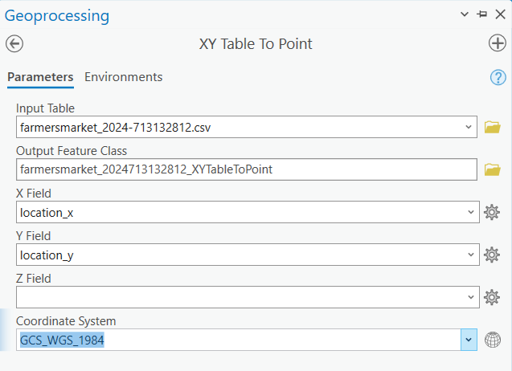

Only selecting farmers' markets within the Northeast for analysis

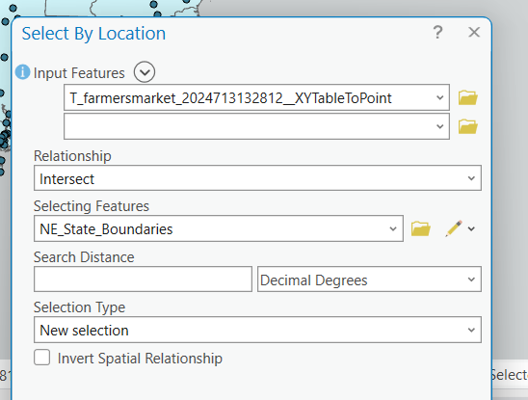

Of the approximately 7,031 farmers markets, 316 of them are in the Northeast

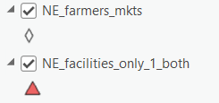

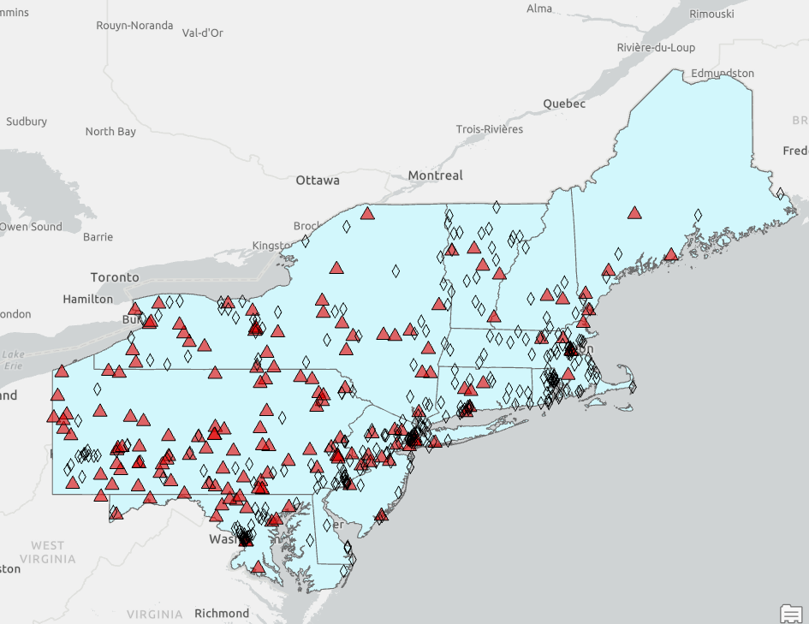

Downloaded data from NASS Quick Search into a spreadsheet in MS excel

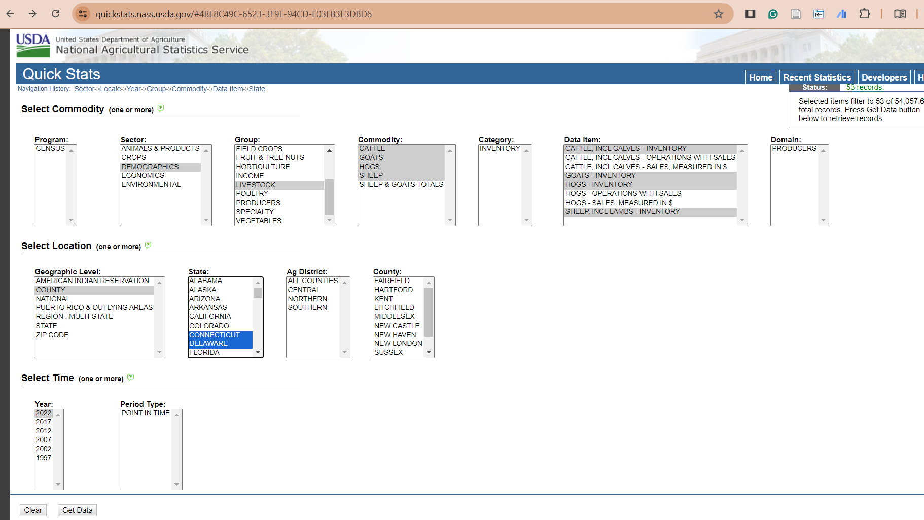

Map showing farmers markets, number of “small” livestock operations, definitions assumed from NASS 2022 Census:

* N operations with beef cows, between 1 and 19 head
* N operations with hogs, between 1 and 49 head
* N operations with sheep, including lambs, between 1 and 99 head
* N operations with goats, any amount of goats

The next step is to clean/ organize/ tidy the data for uploading into ArcGIS Pro - just some basic filtering in MS Excel using the table functions

“Join” the county level data on N operations participating in smaller livestock husbandry (refer to previous definition), as estimated by NASS in 2022

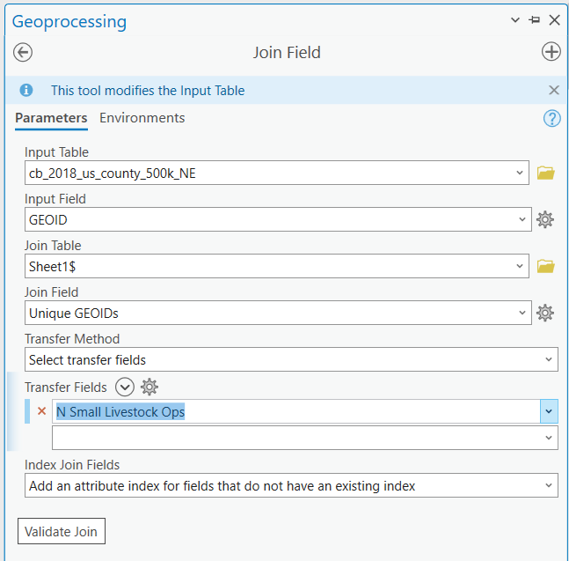

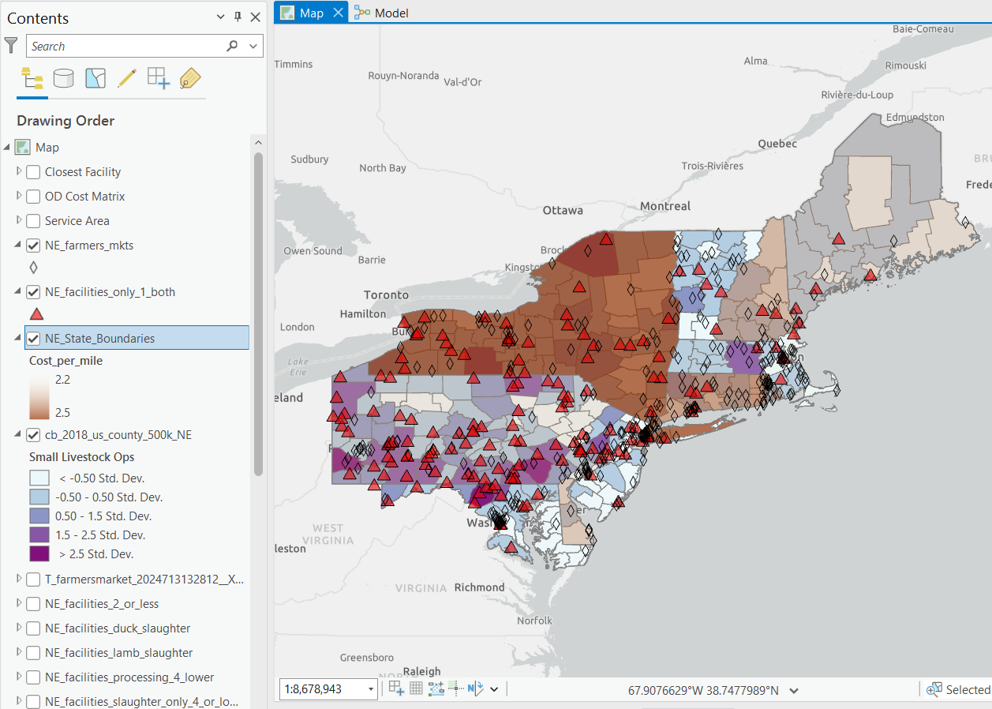

Complete a spatial join to count the number of processing facilities within a county to see if there is a relationship between the location of processing/slaughtering facilities and the number of smaller/multi livestock operations within a county

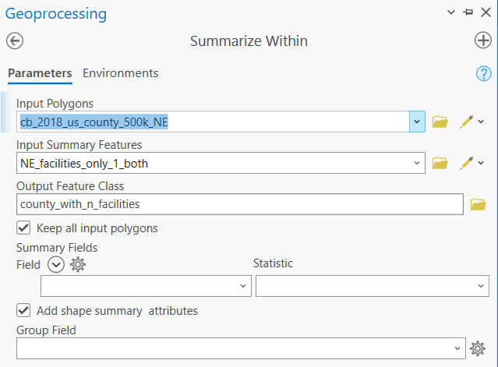

* Repeat summarize within with farmers markets

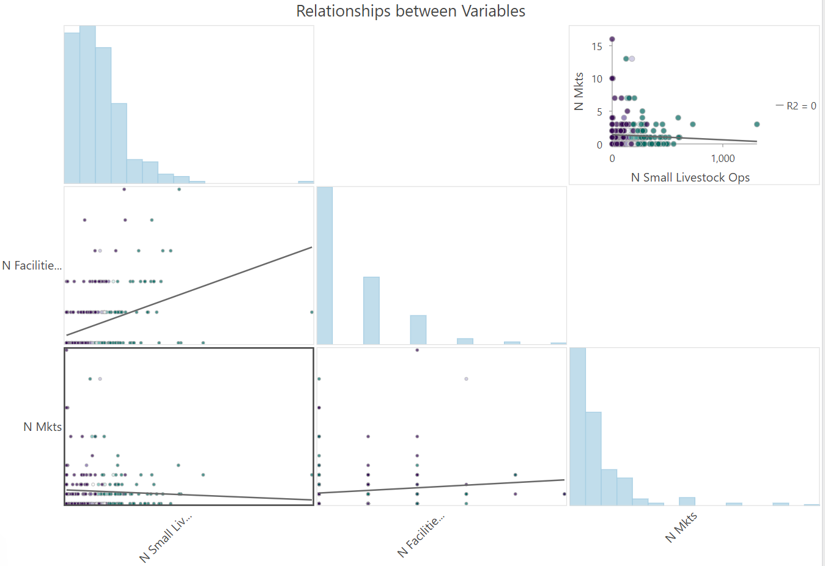

Findings/takeaways from GLR:

* There is a statistically significant, negative relationship between the number of farmers markets and the number of small/niche livestock producers
* There is a statistically significant, positive relationship between the number of small slaughtering and processing facilities, and the number of small/niche livestock producers
* Therefore NE counties that have less farmers markets and more small processors are more likely to have more small/niche processors
  + Almost a mismatch between marketing channels, processors, and producers?

Relationship including cost per mile?

Comparison

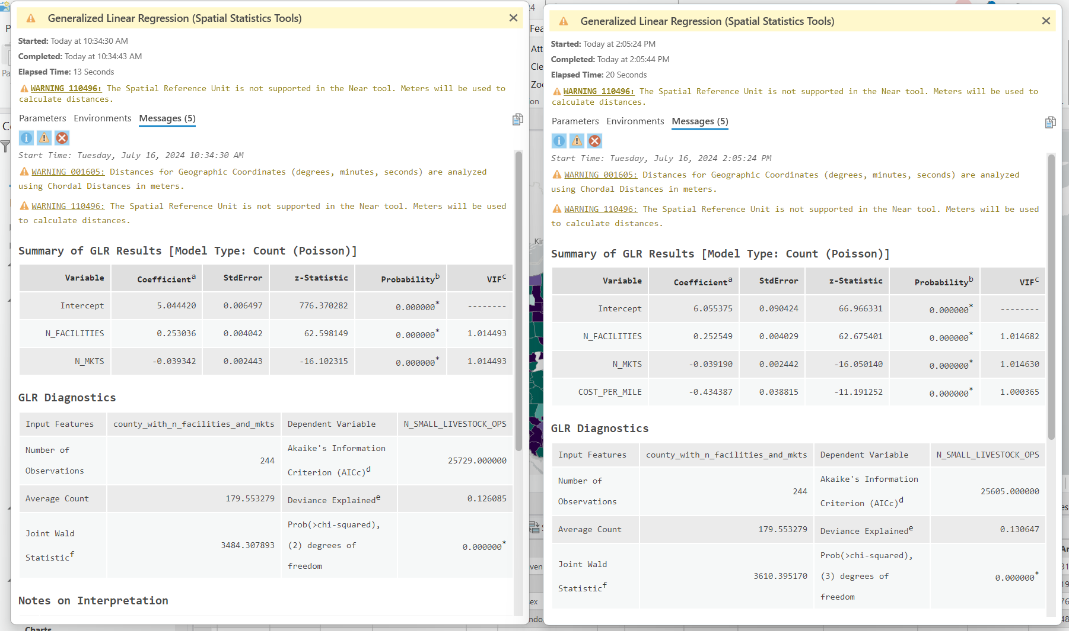

* Adding state values for cost per mile strengthens the result

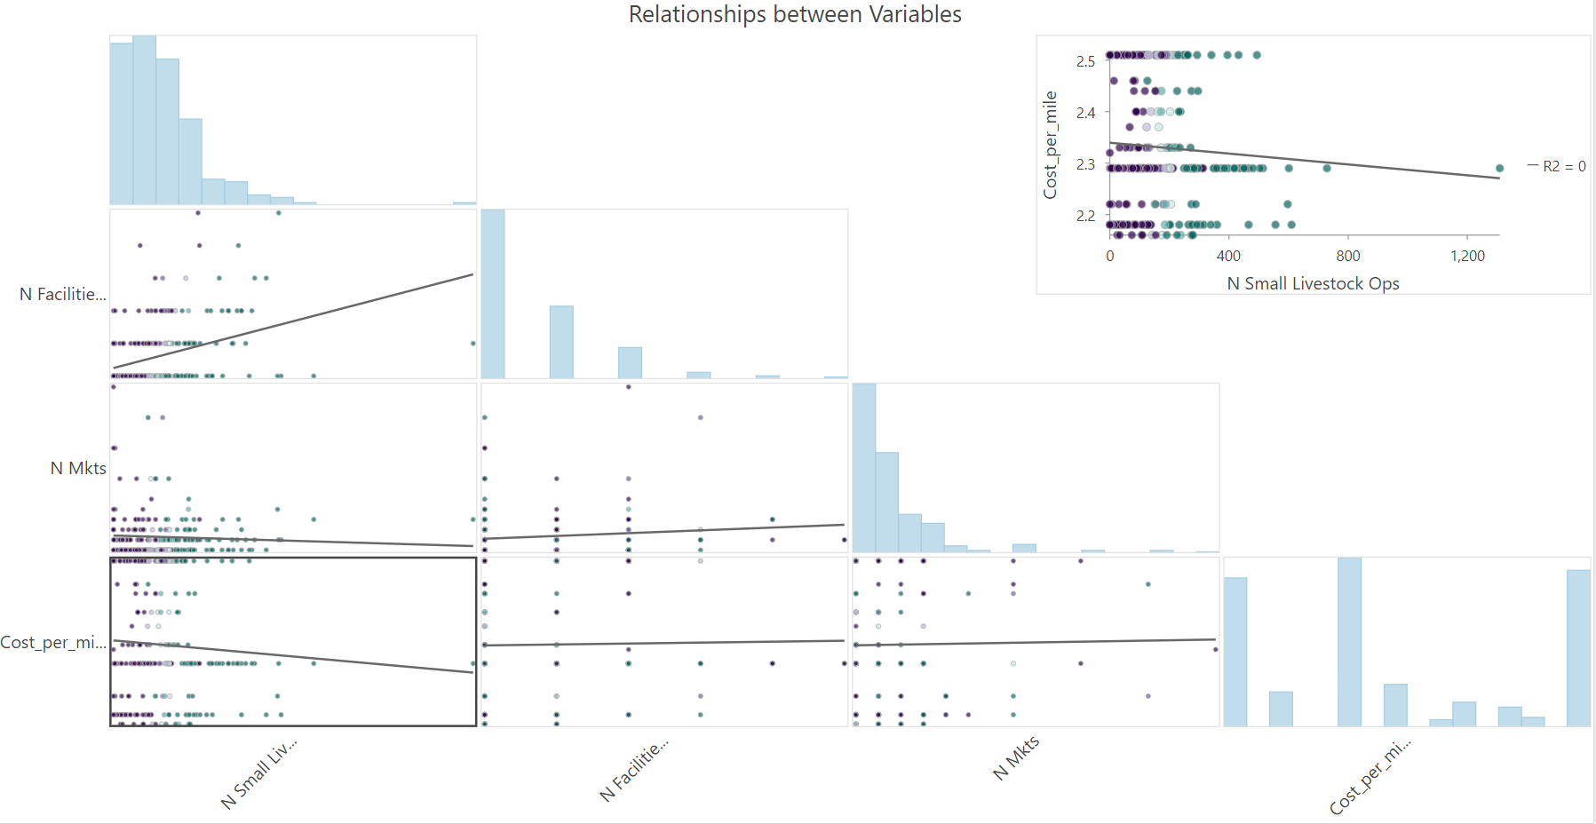

Farmers markets mirror population centers/urban areas, Philadelphia, Washington DC, greater Boston and New York City

Starting to understand the different regions of the Northeast via “spatially constrained multivariate clustering interpretation”

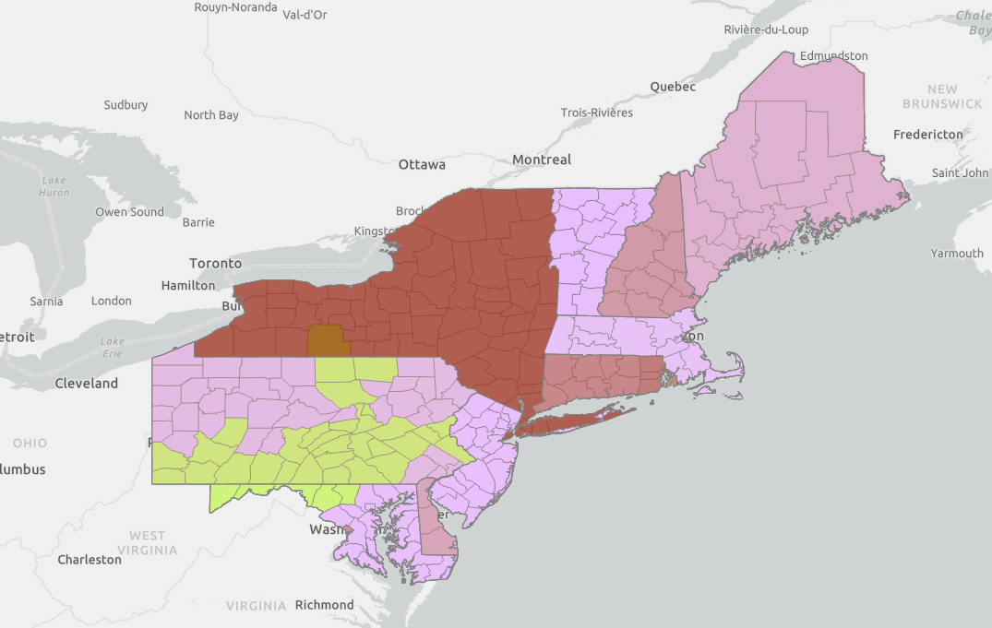

Improve analysis about not just whether there is processing facility within a county, but the amount of overlap with a county within 10 miles of a processing facility

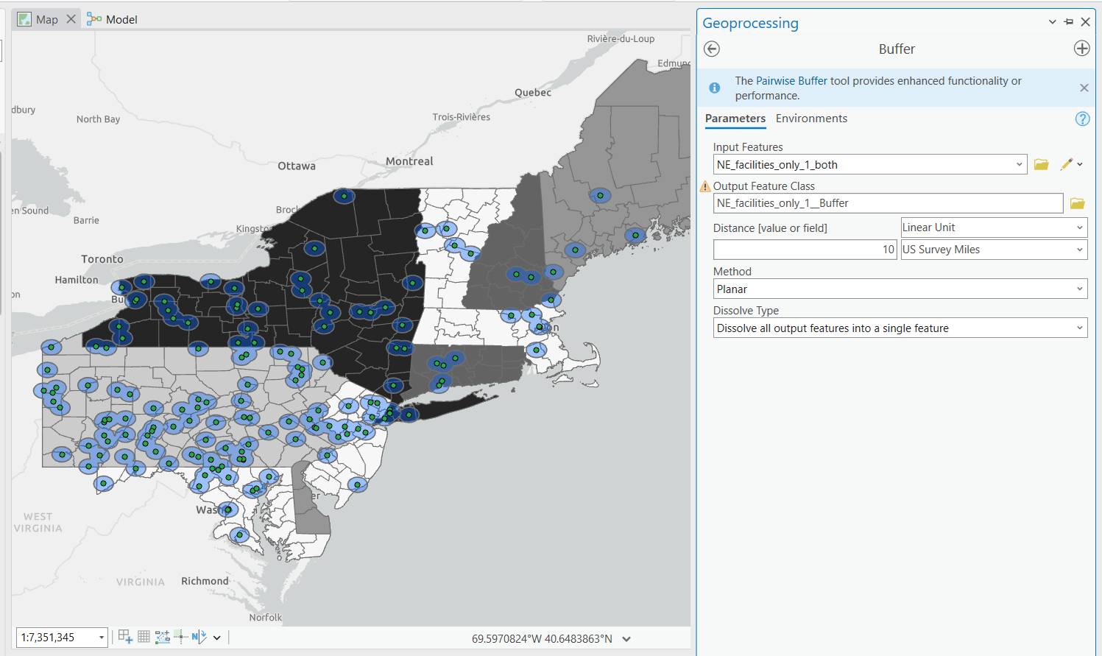

Now remodelling

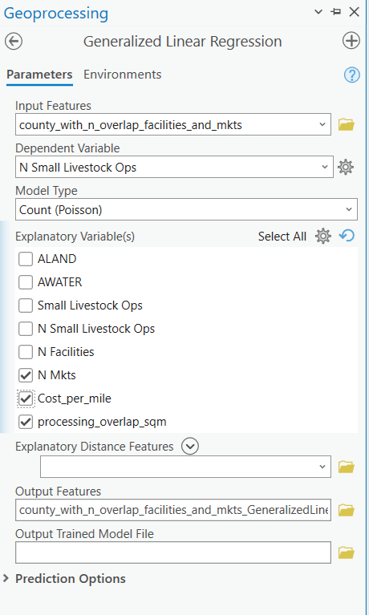

Further strengthened results:  
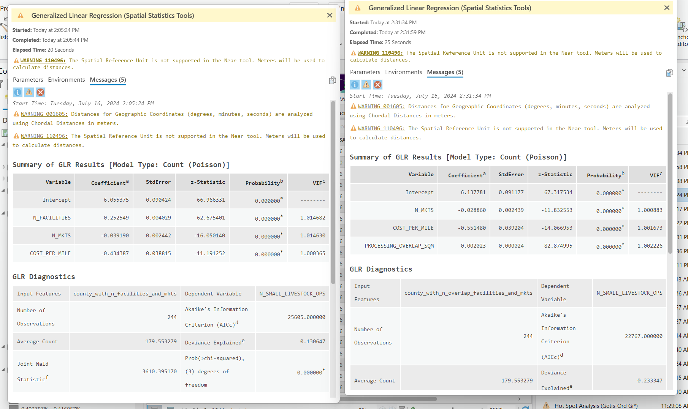

**FInalizing visualization creation**

* For context, census designated overlay
* Download:
* Save data layer with only NE

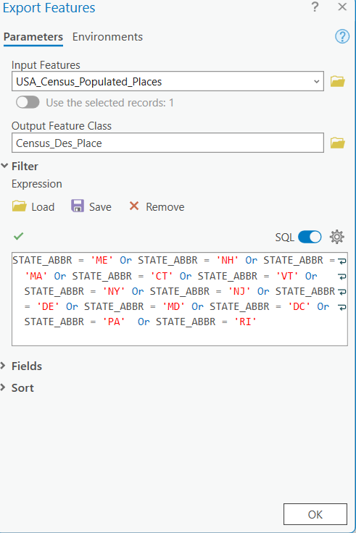

# Cost per mile analysis

**Cost per mile**

To calculate the cost per mile for transporting livestock or poultry in the Northeast region of the U.S., we followed Leslie and Murray (2023) formulas from the American Transportation Research Institute (ATRI). Thus, we included a comprehensive set of expenses: fuel, insurance, tire costs, driver benefits, lease or purchase costs, maintenance, and driver wages. Fuel cost per mile was determined using the average fuel price in June 2024 by state, with a truck fuel efficiency of 6.68 miles per gallon. Fuel data came from the American Automobile Association. In addition, according to ATRI, insurance and tire costs were averaged per mile. Driver benefits and maintenance costs, excluding tire maintenance, were derived from industry standards and best practices. Lease or purchase costs per mile accounted for the amortized value of the vehicle over its useful life, without including depreciation tax benefits. Driver wage per mile was calculated based on the average wage in June 2024 by state, assuming a driver can drive 40.33 miles per hour. Wages data came from recruiter websites such as Ziprecruiter, Glassdoor, and Salaries.com. By summing these costs, we derived a cost per mile for each state, ensuring a realistic and practical evaluation of total truck driving expenses. For detail see table 1. The formula used to calculate the cost per mile was:

$Cost per mile by state: Driver wage per mile + Fuel cost per mile + insurance cost + insurance cost + tires cost + driver benefits + lease or purchase cost + truck maintenance$

Since our model included all Northeast states (Connecticut, Delaware, Maine, Maryland, Massachusetts, New Hampshire, New Jersey, New York, Pennsylvania, Rhode Island, Vermont, Virginia, West Virginia, Washington D.C.), we divided by 14 to obtain the average cost per mile in the region:

Cost per mile by region = (Σ cost per mile by state/ 14)

Leslie, A., & Murray, D. (2023). An analysis of the operational costs of trucking: 2023 update. American Transportation Research Institute.

Cost Per Mile calculation by State, computed in a MS Excel file “Cost per mile NE.xlsx”

| **State** | **Avg wage/hour** | **Fuel** | **Insurance** | **Tires** | **Driver Benefits** | **Lease or Purchase** | **Maintenance** | **Driver wage** | **Fuel** | **Cost per mile** |
| --- | --- | --- | --- | --- | --- | --- | --- | --- | --- | --- |
| Connecticut | $37.00 | $4.021 | $0.088 | $0.045 | $0.207 | $0.366 | $0.217 | $0.82 | $0.67 | $2.44 |
| Delaware | $36.00 | $3.711 | $0.088 | $0.045 | $0.207 | $0.366 | $0.217 | $0.82 | $0.62 | $2.37 |
| Maine | $32.00 | $4.069 | $0.088 | $0.045 | $0.207 | $0.366 | $0.217 | $0.00 | $0.68 | $2.33 |
| Maryland | $27.42 | $3.832 | $0.088 | $0.045 | $0.207 | $0.366 | $0.217 | $0.82 | $0.64 | $2.18 |
| Massachusetts | $28.00 | $4.056 | $0.088 | $0.045 | $0.207 | $0.366 | $0.217 | $0.82 | $0.68 | $2.22 |
| New Hampshire | $35.00 | $4.039 | $0.088 | $0.045 | $0.207 | $0.366 | $0.217 | $0.82 | $0.67 | $2.40 |
| New Jersey | $28.38 | $3.729 | $0.088 | $0.045 | $0.207 | $0.366 | $0.217 | $0.82 | $0.62 | $2.18 |
| New York | $38.46 | $4.248 | $0.088 | $0.045 | $0.207 | $0.366 | $0.217 | $0.82 | $0.71 | $2.51 |
| Pennsylvania | $29.47 | $4.260 | $0.088 | $0.045 | $0.207 | $0.366 | $0.217 | $0.82 | $0.71 | $2.29 |
| Rhode Island | $37.00 | $4.132 | $0.088 | $0.045 | $0.207 | $0.366 | $0.217 | $0.82 | $0.69 | $2.46 |
| Vermont | $26.00 | $3.951 | $0.088 | $0.045 | $0.207 | $0.366 | $0.217 | $0.82 | $0.66 | $2.16 |
| Virginia | $47.00 | $3.814 | $0.088 | $0.045 | $0.207 | $0.366 | $0.217 | $0.82 | $0.64 | $2.66 |
| West Virginia | $26.61 | $3.847 | $0.088 | $0.045 | $0.207 | $0.366 | $0.217 | $0.82 | $0.64 | $2.16 |
| Washington D.C. | $28.03 | $3.709 | $0.088 | $0.045 | $0.207 | $0.366 | $0.217 | $0.82 | $0.62 | $2.17 |
| Avg NE | $32.60 | $3.96 | $0.09 | $0.05 | $0.21 | $0.37 | $0.22 | $0.76 | $0.66 | $2.32 |

## Cost per mile geography integration

# Spatially Constrained Multivariate Clustering Analysis (Completed in ArcGIS Pro)

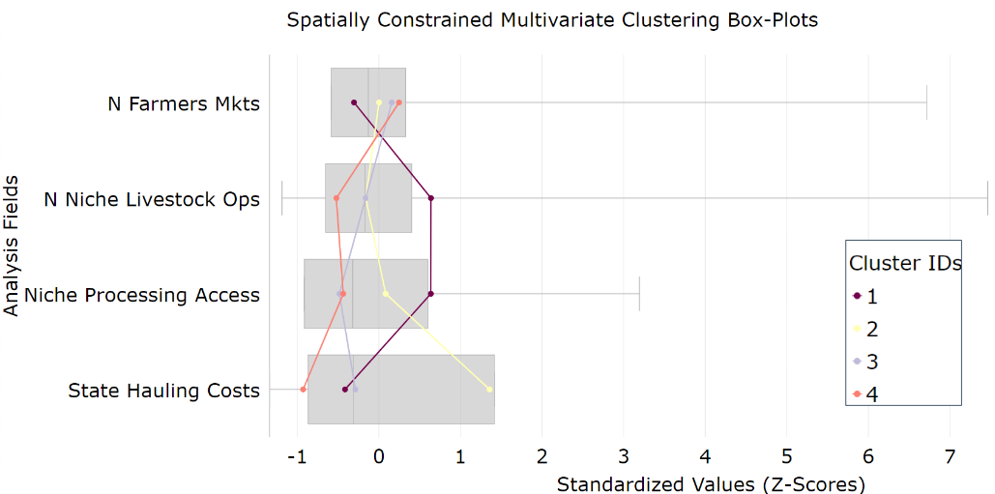

## Results and interpretation:

Visual representation of the “Spatially Constrained Multivariate Clustering” results

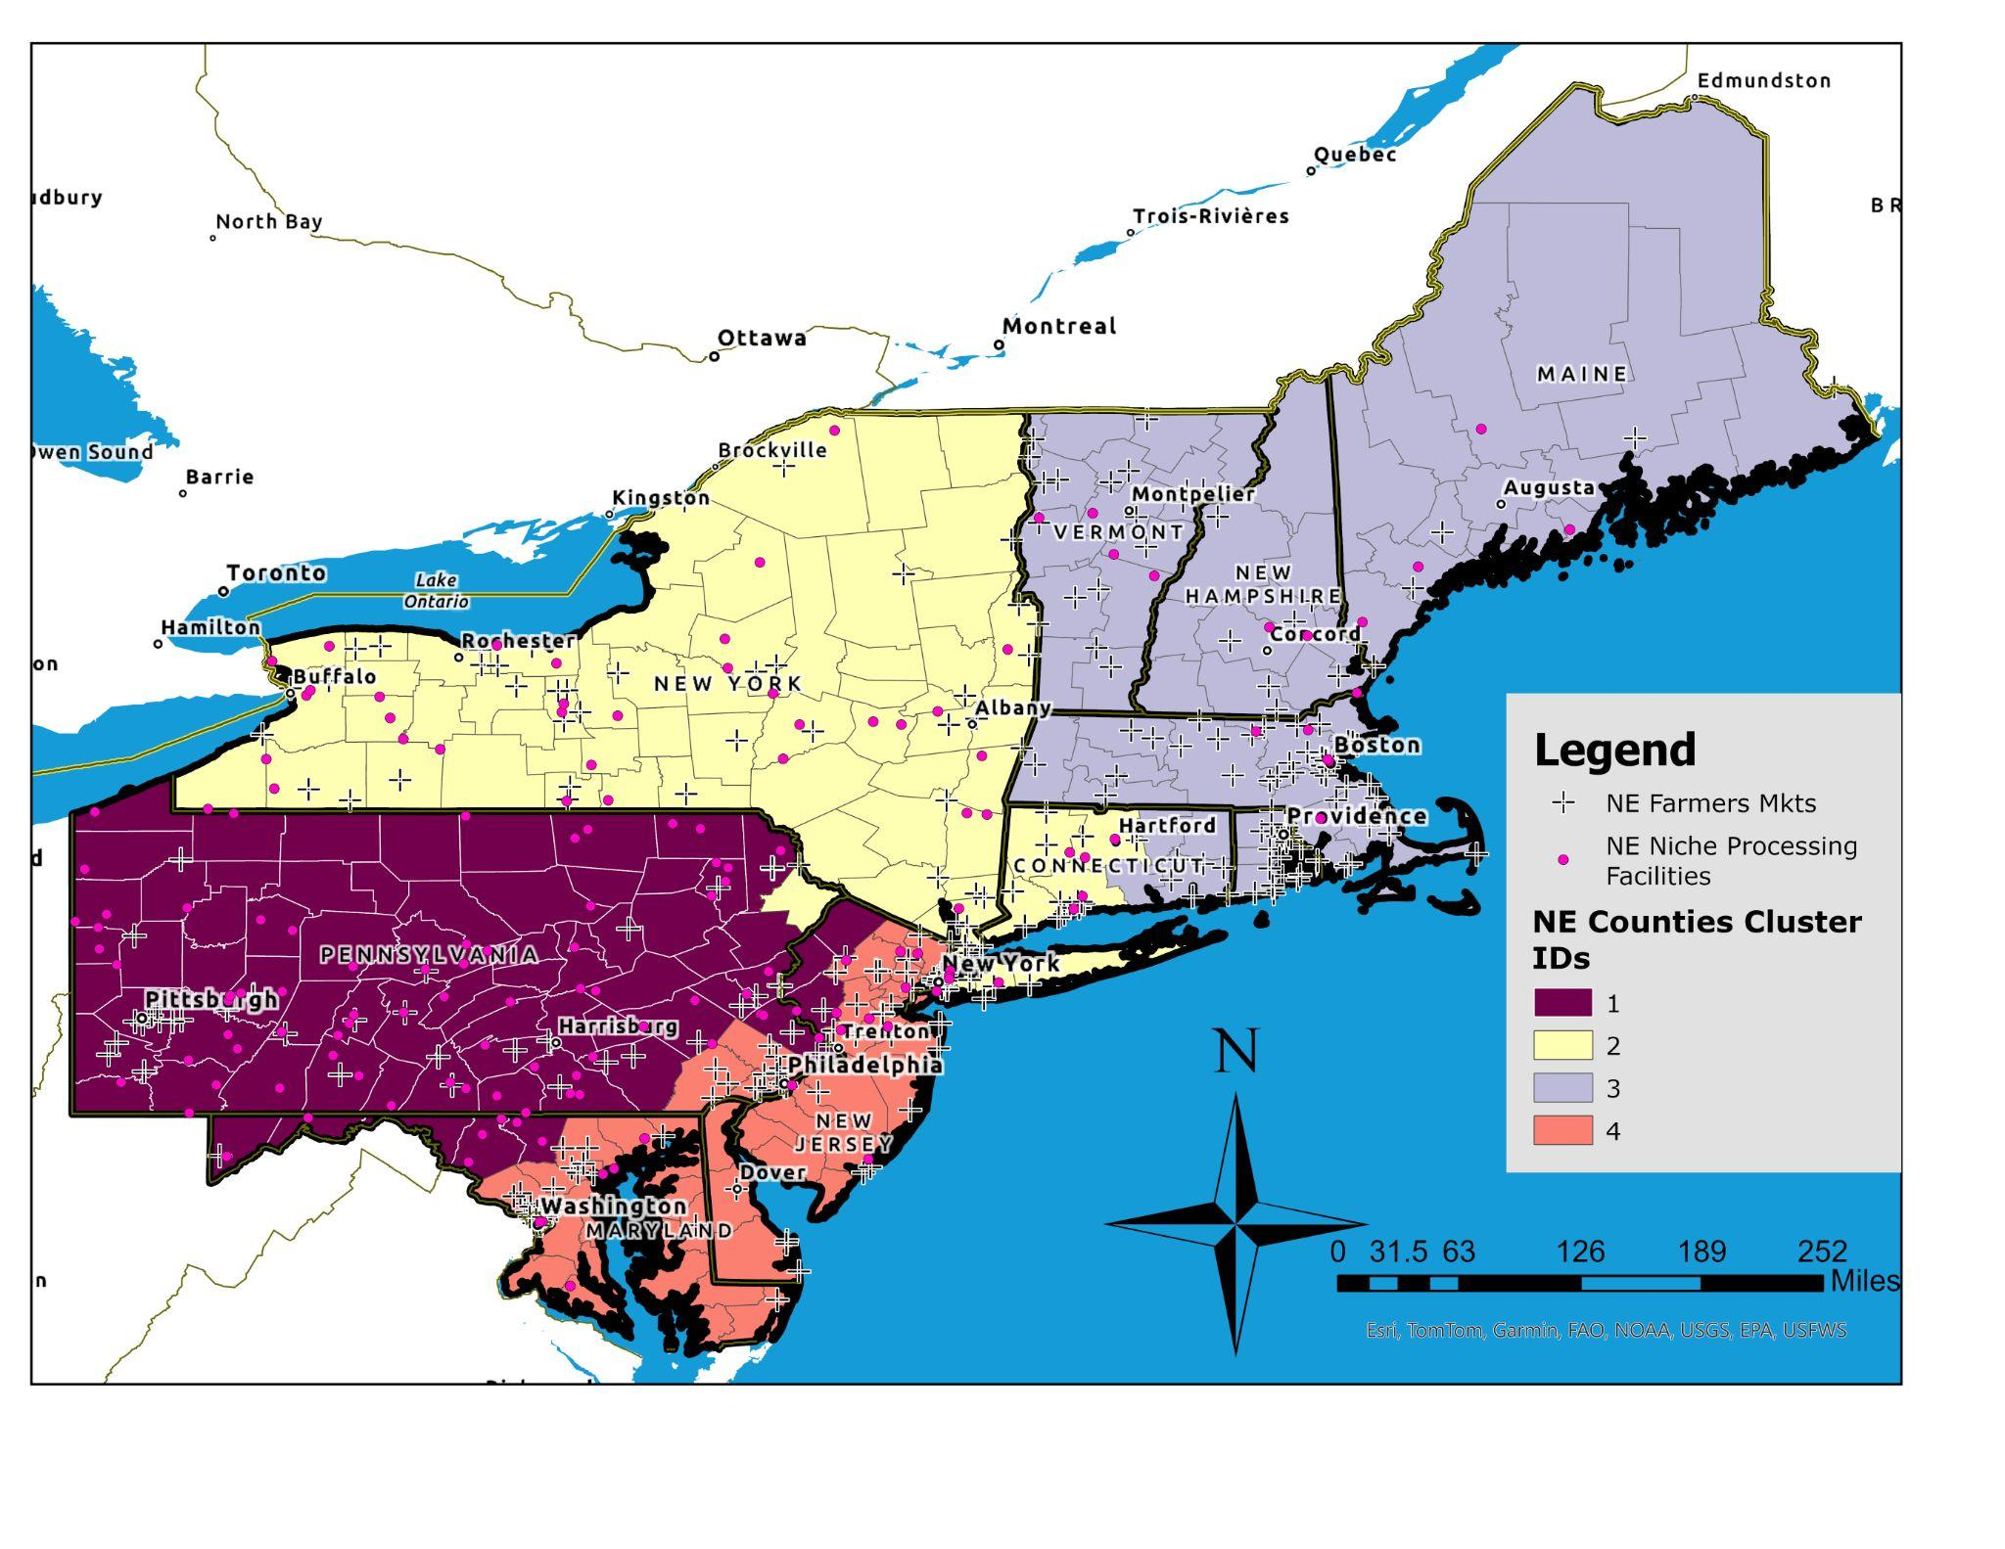

Interpretation from the “Spatially Constrained Multivariate Clustering Box-Plots”

| Cluster ID | Cluster Descriptions/Analysis | Local Food Needs |
| --- | --- | --- |
| **1 (Dark Purple)** | The area has the most niche processing facilities and specialty livestock farmers in the NE; however, it has the least access to farmers' markets. | Additional farmers markets and direct market channels for livestock producers to sell through. |
| **2 (Yellow)** | Area with the highest hauling costs but benefits from access to farmers markets and niche processing facilities, offering direct sales and specialized processing opportunities. | The area would benefit from reduced economic costs for livestock hauling. |
| **3 (Light Purple)** | The cluster has sufficient access to farmers' markets while having average regional hauling costs and specialty livestock operations. | This area needs general support for small-scale slaughtering and processing infrastructure. |
| **4 (Salmon)** | The cluster has the lowest hauling costs and the most access to farmers markets, yet it has the fewest niche livestock operations. | The cluster would benefit most from direct support for niche livestock producers and additional slaughtering and processing infrastructure. |

# Takeaways

## Limitations of this analysis/work

* We do not know what the remaining capacity or lead/wait time is for the processing and slaughtering facilities
* The current analysis only considers farmers' markets as demand points/ direct market channels. Future analysis should include other regional, direct market channels through which livestock producers could sell.

1. https://www.fsis.usda.gov/inspection/establishments/meat-poultry-and-egg-product-inspection-directory